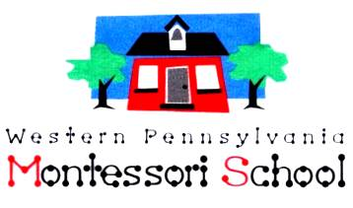

November 21, 2017
Western Pennsylvania Montessori School shall provide a safe, secure, and nurturing atmosphere in which each child may develop and grow emotionally, socially, intellectually, and physically by receiving a well-rounded experience based on Montessori philosophy.
Dear Families and Friends of WPMS,

It’s that time of year again when we have the opportunity to show our support for the Western Pennsylvania Montessori School by contributing to its Annual Fund Campaign with our year end giving.

This year, WPMS is celebrating its 52nd anniversary! As you know, we are the first Montessori school in Western Pennsylvania and also one of the few “Not for Profit” Montessori Schools. Dr. Maria Montessori founded the Montessori movement in January 1907 when she began her “casa de bambini” in Italy. Please help us celebrate both of these anniversaries with your financial contribution.

Years ago, we began a brick walkway at our entrance to celebrate our 40th anniversary. Many of you have already purchased a brick. If you have not had an opportunity to reserve your family brick, please order one today! It would be great to have as many bricks as possible representing all the wonderful families who have attended WPMS since it opened in 1965. We have spaces for 4” x 8” pavers at $100.00 each. The pavers ordered now will be placed on the walk in the spring of 2018.

Please see the attached form to make a monetary contribution, or to order bricks. Your contributions are extremely important to keeping our school looking good and functioning at a top level of learning for the children. You may not know or be aware that none of the tuition money pays for capital improvements for the school. Therefore we must fundraise.

Your contributions have paid for, installing new flooring in two of our classrooms, adding a patio enclosure at the front entrance, and replaced the fence. Our future projects that we hope to complete include a new playground, and new flooring in the remaining classrooms and hallways. We hope that you will help us continue to keep our school beautiful.

Thank you for being a part of the special memories of Western PA Montessori School.

Sincerely,

Jamie Campbell,
Head of School

2379 Wyland Avenue, Allison Park, PA 15101 phone (412) 487-2700 fax (412) 487-7048

