The Peace Rose in the Classroom and at Home

Peace is what every human being is craving for, and it can be brought about by humanity through the child. ~ Maria Montessori

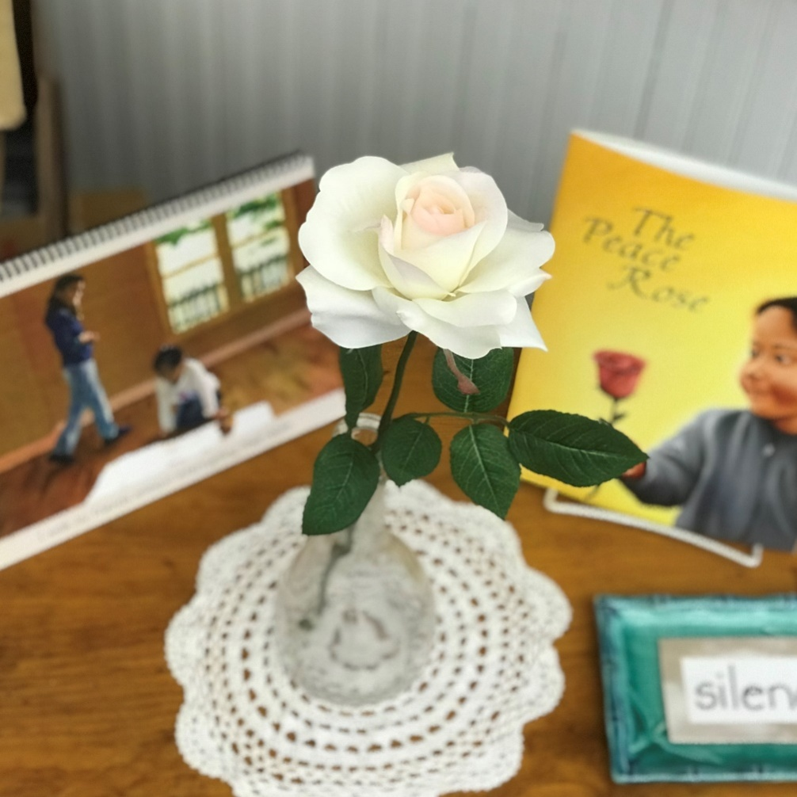
Photo: The Peace Rose displayed in our classroom.

We are all longing for ways to teach children about peace in light of the violent incidents in recent months and years. Yet peace feels so evasive these days -- how can we bring this to our children’s lives?

While we often think of school as a place to learn the “three Rs,” the Montessori classroom strives to be a place where children learn to live in harmony with each other and the world, learning problem solving and communication skills that they carry into adulthood. Dr. Maria Montessori frequently repeated this call:
Everyone talks about peace, but no one educates for peace. People educate for competition and this is the beginning of any war. When we educate to cooperate and be in solidarity with one another, that day we will be educating for peace.

In many Montessori classrooms, including ours, you will find a quiet place referred to as a “Peace Area.” The Peace Area (or “Peace Shelf,” “Peace Corner,” etc.) usually includes materials that promote stillness and reflection. It also displays work to celebrate diversity and promote global awareness, as well as teach interpersonal skills.

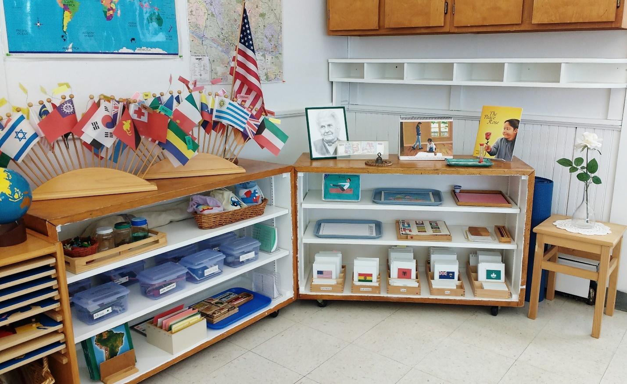Photo: The WPMS Blue Room’s Geography and Peace Shelves

Interpersonal communication and problem-solving can be challenging for young children who are still learning to recognize the “otherness” of people. Children below the age of seven are egocentric, the center of their own universe. The concept of the Peace Rose is a concrete way for children to practice recognizing the needs and emotions of other children.

To introduce the Peace Rose, we read the book The Peace Rose by Alicia Olson. (Available from Montessori Services and other sellers.) This sweet book uses simple text and painted illustrations to show how children can use the Peace Rose to share their feelings in response to various age-appropriate situations.
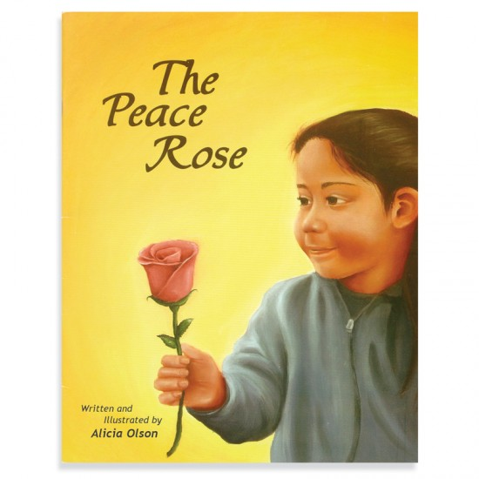

After reading the book, we spend time role-playing the communication process. A typical role-play might be the following:

Child 1 and Child 2 face each other, either sitting or standing.
Child 1 holds the Peace Rose: “[Child’s name], I didn’t like it when you knocked over my Pink Tower. It made me feel sad.”

Often the teacher will need to prompt the child to express their feeling. Children have a limited vocabulary for emotions, and may need help learning the words that describe various feelings. As a parent, you can begin helping your child identify their emotions as soon as they can express them.

Child 1 presents the Peace Rose to Child 2.
Child 2, holding the Peace Rose: “I see that you are sad because I knocked over your Pink Tower, [child’s name]. Can I help you pick it up?”

Encourage the listening child to reply by repeating the first child’s statement. “I’m sorry” is not always a necessary phrase (although you will hear it often). It is most important is that the offending child recognizes the feelings of the victimized child and seeks to make amends. Again, the adult may need to coach the children -- this is why we practice!

Child 2 presents the Peace Rose to Child 1.
Child 1, holding the Peace Rose: “Yes, thank you.”
Child 1 presents the Peace Rose to Child 2.
Child 2, holding the Peace Rose: “I’ll be more careful next time.”

End scene!

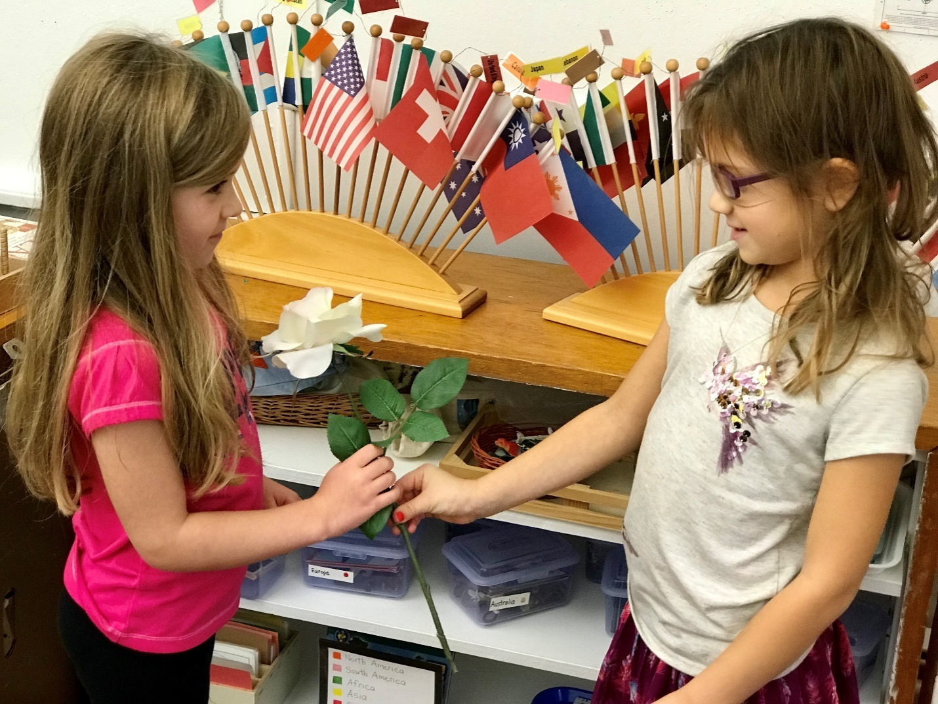
Photo: Practicing talking with the Peace Rose

We practice using the Peace Rose throughout the year. As children spend more time in the classroom, they become increasingly adept at resolving conflicts without a teacher’s intervention.

So how can you use this tool at home? While the conflicts may be different, the basic communication skills remain the same. Let your child choose a peace object, and place it within reach. You may even consider setting up your own Peace Area. During times without conflict, practice reflective speaking and listening with your child. Encourage role-playing between siblings. Remember, this is a learned skill -- you will have success only with ongoing practice. As conflicts change, coach your child through a new response. Need ideas for a script? Ask your child’s teacher -- we’re happy to help!

